News Release
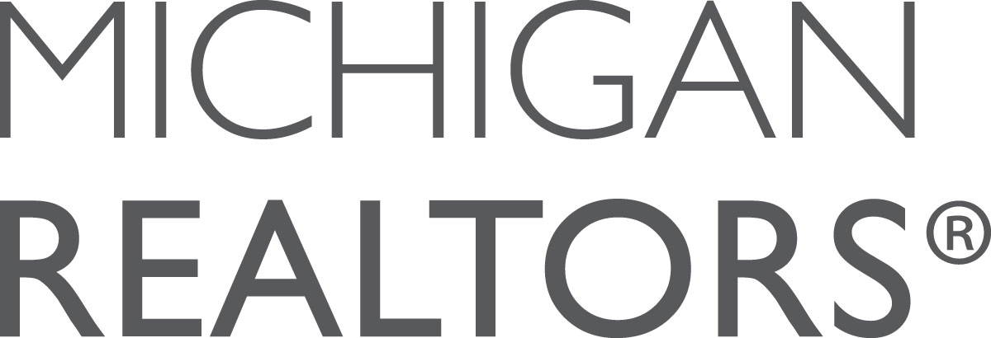
For more information contact:
Joe Kras, Communications Director
Michigan Realtors®
jkras@mirealtors.com
(517) 334-5535

For immediate release

(local association office) Names (full name) Realtor® of the Year

The (local association office) has named (full name) as its 2016 Realtor® of the Year. This award is given in recognition of outstanding leadership and service for the association, the community and the real estate industry.

Award winners were chosen by their peers and recognized both locally and at The Convention, held at the Soaring Eagle Casino & Resort, October 5-7, 2016 in Mt. Pleasant. Nominees are evaluated on their community service, education, business accomplishments and service to the Realtor® organization at the local, state and national levels.

(add quote(s) here)

The Michigan Realtors® is a 28,000 plus member trade association which protects the rights of private property owners while serving as the primary source for Michigan housing and real estate data. The Michigan Realtors® is comprised of 42 Local Realtor® Associations, which adhere to a strict Code of Ethics, established by the National Association of Realtors®.

